BUSH-BAR WEBAPP DOCUMENTATION

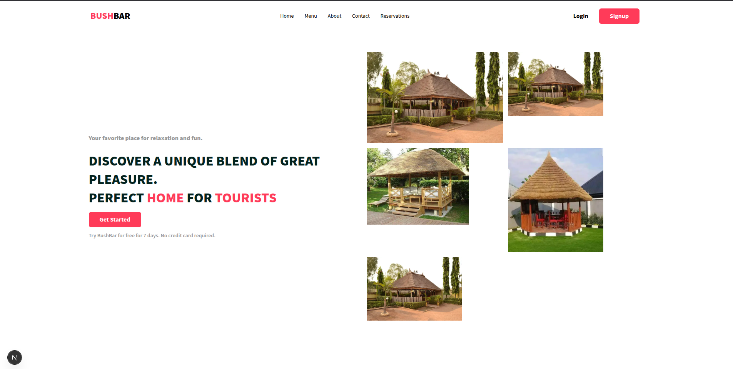

The Main Section:

Overview
The homepage serves as the landing page for Bush Bar, designed to introduce users to our brand and guide them toward key sections of the site such as products, services, or contact information.

1. Overall Layout & Structure:
- Header (Top Navigation Bar):
  - Logo/Brand: "BUSHBAR" (Left aligned, prominent).
  - Navigation Links (Horizontal, Right of Logo):
    - "Home"
    - "Menu"
    - "About"
    - "Contact"
    - "Reservations"
  - Authentication Buttons (C.T.A):
    - "Login" (Text button)
    - "Signup" (Pink button, likely primary call to action)
- Main Content Area: Divided into two primary sections:
  - Left Section (Textual Content & Call to Action):
    - Headline/Tagline: "Your favorite place for relaxation and fun."
    - Main Heading: "DISCOVER A UNIQUE BLEND OF GREAT PLEASURE. Perfect Home for tourist (WITH TYPEWRITING EFFECT) (Bold, large font).
    - Call to Action Button: "Get Started!" (Pink button).
    - Sub-text: "Try Bushbar for free for 7 days. No credit card required." (Smaller font, below CTA).
  - Right Section (Image Gallery/Showcase):
    - Arrangement of five images, possibly in a masonry or grid-like layout.
    - All images depict "bush bar" or hut-like structures, suggesting the establishment's aesthetic.

BUSH BAR SIGN UP PAGE

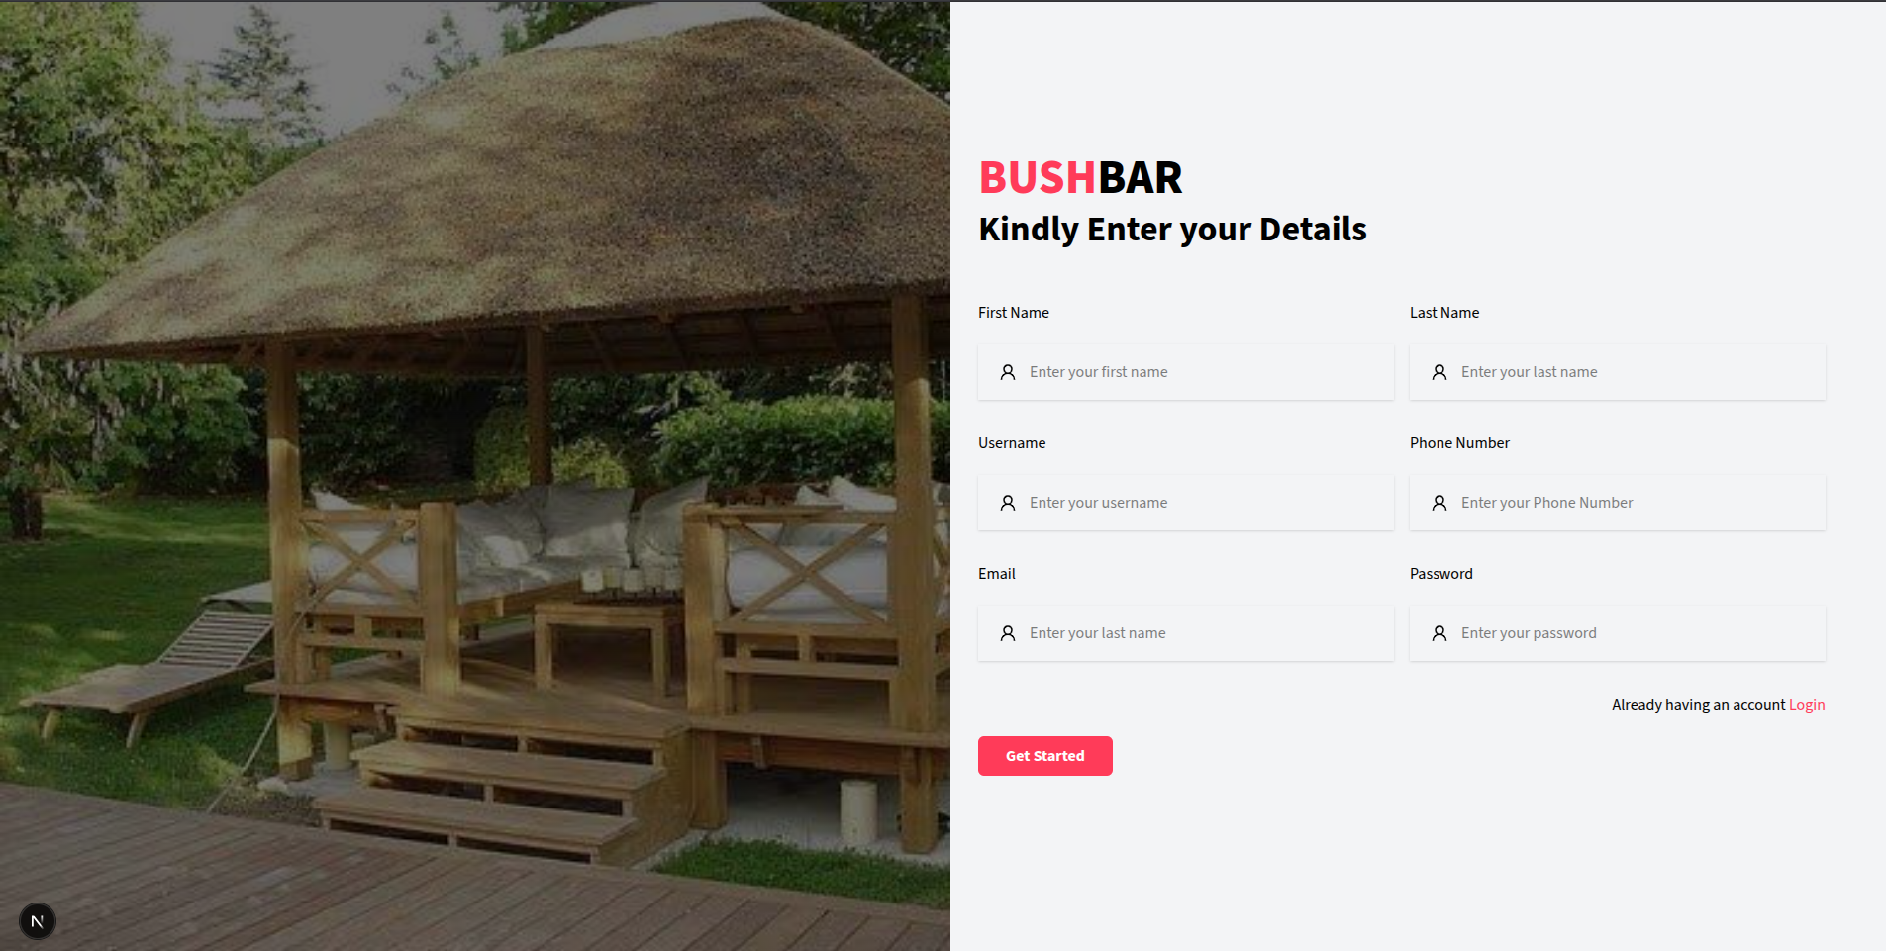
Description: This document details the UI elements and inferred functionality of the "Bushbar" web application's signup form, as depicted in the provided screenshot. This page is likely accessed after clicking "Get Started!" or "Signup" from the landing page.

1. Overall Layout & Structure:
- Split Layout (Two-Column): The page is clearly divided into two main vertical sections.
  - Left Section (Visual/Background):
    - Dominated by a large image of a "bush bar" or thatched gazebo, consistent with the branding seen on the landing page. This serves as a visual background or branding element for the form.
    - A small, dark circle with a white "N" is present in the bottom-left corner, mirroring the landing page's footer element.
  - Right Section (Form/Interaction):
    - Contains the core signup form elements.
    - Branding/Title: "BUSHBAR" (Pink, prominent) followed by "Kindly Enter your Details" (Dark text, subtitle).
    - Input Fields: Organized into pairs, suggesting a responsive grid or flexbox layout.
    - Call to Action Button: "Get Started" (Pink button).
    - Login Link: "Already having an account. Login" (Small text with "Login" as a clickable link).

2. UI Elements & Components:
- Text Inputs:
  - First Name
  - Last Name
  - Username
  - Phone Number
  - Email
  - Password
  - Each input field has a placeholder text (e.g., "Enter your first name") and a leading icon (person or lock, indicating the type of input).
- Button:
  - Get Started (Primary CTA, pink, rounded corners).
- Links:
  - Login (Text link, likely navigates to a login page).
- Headings/Titles:
  - BUSHBAR (Likely <h2> or <h3>, styled in pink).
  - Kindly Enter your Details (Likely <p> or <h4>).
- Image: Large <img> element on the left side.

BUSH BAR Listing Page
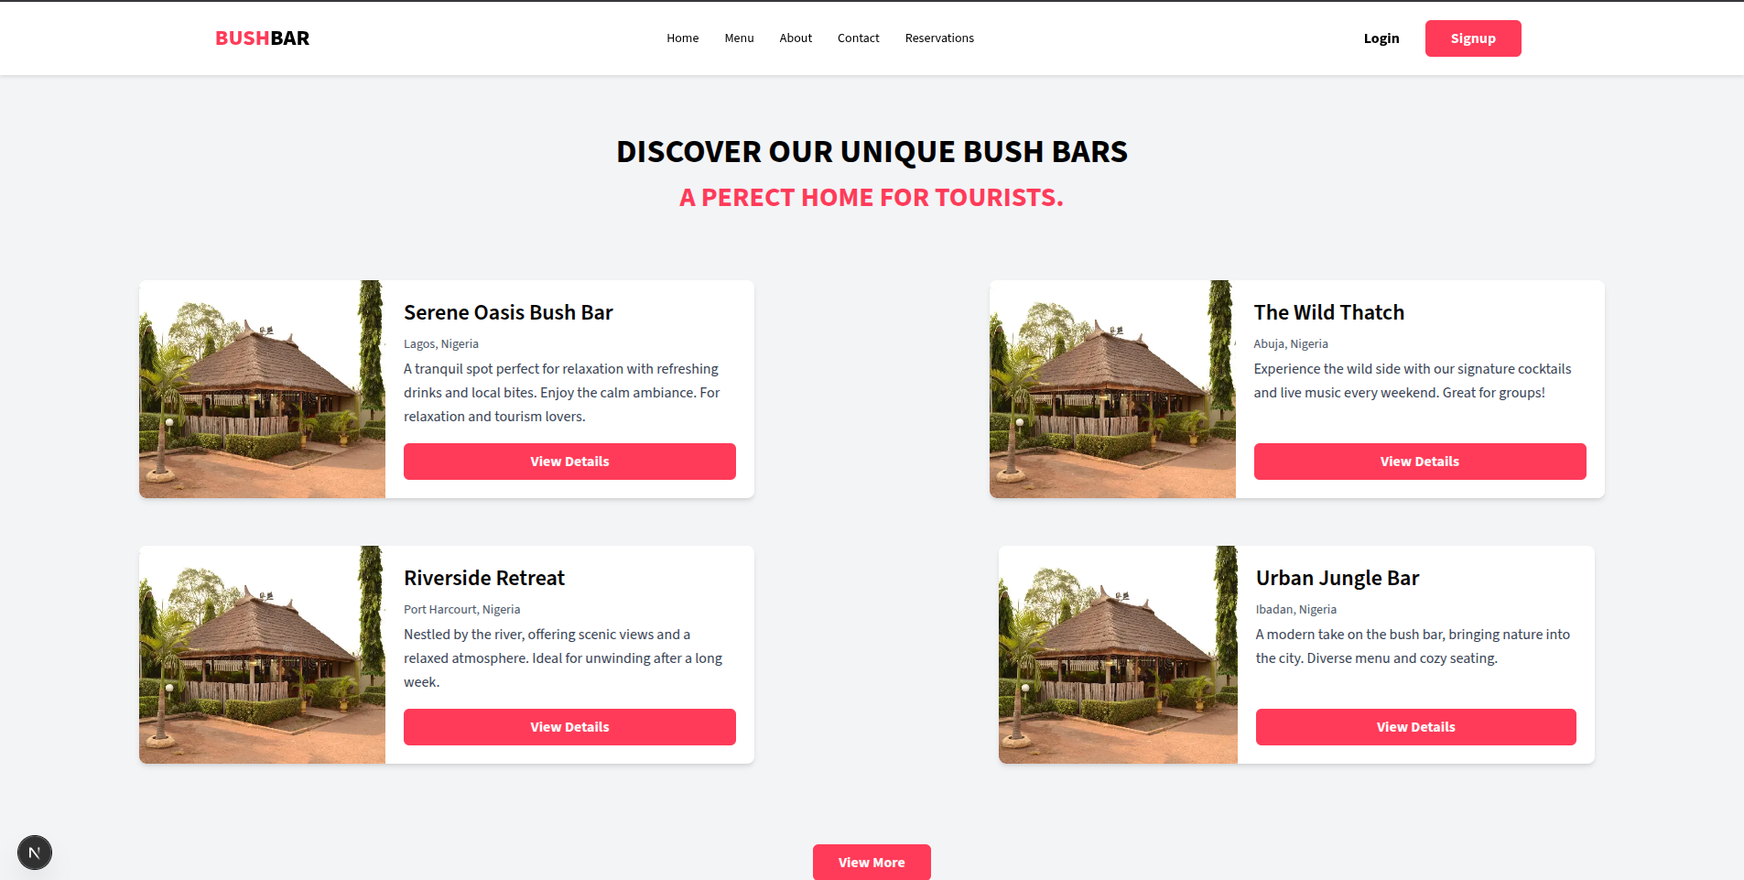

Overall Layout & Structure:
- Header (Top Navigation Bar):
  - Logo/Brand: "BUSHBAR" (Left aligned).
  - Navigation Links (Horizontal, Right of Logo): "Home", "Menu", "About", "Contact", "Reservations".
  - Authentication Buttons (Far Right): "Login" (Text button), "Signup" (Pink button, primary call to action).
  - This header is consistent with the initial landing page screenshot.
- Main Content Area:
  - Heading: "DISCOVER OUR UNIQUE BUSH BARS" (Centered, prominent).
  - Bush Bar Listing (Grid/Two-Column Layout):
    - Displays four distinct "bush bar" cards.
    - Each card is a self-contained unit featuring an image, name, location, a brief description, and a "View Details" button.
    - The cards are arranged in a 2x2 grid, suggesting a responsive design that might adapt to a single column on smaller screens.
- Footer (Bottom Left):
  - Small, dark circle with a white "N" inside. This is consistent across all provided screenshots.

2. UI Elements & Components:
- Bush Bar Card Component (Repeated):
  - Image: Prominently displays an image of the bush bar.
  - Name: Bold text (e.g., "Serene Oasis Bush Bar").
  - Location: Smaller text (e.g., "Lagos, Nigeria").
  - Description: A short snippet summarizing the bush bar's offering.
  - Button: "View Details" (Pink, indicating a primary action).
- Headings: <h1> for "DISCOVER OUR UNIQUE BUSH BARS" and <h3> or similar for individual bush bar names.
- Buttons & Links: As described in the header section, consistent with previous pages.

Notes
- Designed by [George] using [Framework or Tool, e.g, Nextjs/Tailwind].
- Last updated: June 20, 2025

